**Driver Duty Work Time**

***Work-flow to Use Driver Duty Work Time***

The Driver Duty Work Time preference is accessed through **Load Template** and only one instance of it is permitted.

***Preference Overview***

This preference sets a sliding penalty for driver duty work time by time interval. See for example, **Figure 1-1** below.



The table in **Figure 1-1** is customer specific.

The penalties as shown work like this: The base penalty is 50. For each hour between

00:00 and 04:00, the penalty is pro-rated from zero for zero time increasing by 50 per hour for 4 hours to a maximum 0 4 * 50 = 200.

For 04:00 to 07:00, you have the 200 penalty for the first four hours. For the next three hours, an additional penalty is pro-rated from zero increasing to 0.5 * 50 per hour for an additional three hours making a total of 200 + 0.5 * 50 * 3 = 275 for seven hours.

The same pattern continues for the rest of the table.

The decimal numbers that you enter for each time range are multipliers for the base pen- alty per hour within the range.

***Templates Available from Optibus***

***Driver Duty Work Time Preference***

**Purpose:**

As stated in the Overview **Prerequisites:** None. **Opening Dialog:**

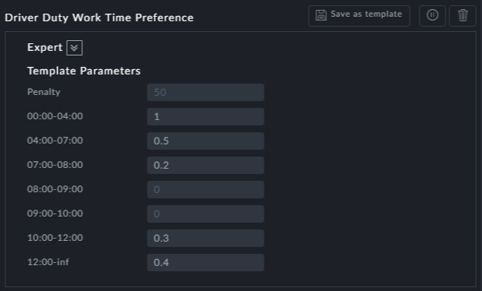

*Figure 1-1: Duty work time penalties*